# GNEEVEGUILLA N.S.

# ADMINISTRATION OF MEDICINE / ANAPHYLAXIS POLICY

Gneeveguilla NS is a Catholic primary school in Gneeveguilla, Kerry, under the Patronage of the Catholic Bishop Ray Browne. There are currently (2023) 5 mainstream classes, with single and mixed-graded classes in each.

**INTRODUCTORY STATEMENT**

This policy is concerned with the whole school approach to the health care and management of members of the school community suffering from serious specific allergies.

The school is not in a position to guarantee a completely allergen free environment. Our aim is to minimise the risk of exposure, encourage self-responsibility, plan for effective response to possible emergencies and become an 'allergy aware' environment. The school recognises that a number of community members suffer from potentially life-threatening allergies to certain foods, or toxins from peanuts, nuts and eggs.

## Rationale

The intent of this policy is to:

1. Identify risks for anaphylaxis.
2. Minimise the risk of any student suffering allergy induced anaphylaxis whilst at school or attending any school related activity.
3. Ensure staff are properly prepared to manage such emergency situations should they arise.

## Definitions

**Allergy:** A condition in which the body has an exaggerated response to an allergen. **Allergen:** A normally harmless substance that triggers an allergic reaction in the immune system of a susceptible person.

**Anaphylaxis or anaphylactic shock:** A sudden, severe and potentially life-threatening allergic reaction to food, stings, bites, or medicines.

**Adrenaline Auto-injector:** A medical device for injecting a measured dose or doses of adrenaline by means of auto-injector technology. A number of brands used include Emerade®, EpiPen®, Jext®

**Anaphylaxis Action Plan:** A clear document with information on how to recognise anaphylaxis and how to administer the child's adrenaline auto-injector and emergency contact details.

## Guidelines

The school's key guidelines are to:

* Identify the student with the food allergy in the school.
* Have a written *Anaphylaxis Action Plan* for each child at risk of anaphylaxis. This plan must be written by child's doctor and parents *(see Appendix I).*
* The avoidance of allergens followed at home should be applied to the classroom.
* There is a 'no share food' policy in relevant classroom.
* Where food is consumed, the following must be in place:
  + hand washing/ sanitising (in so far as possible)
  + no food sharing
  + routine cleaning of surfaces where food is consumed to avoid cross contamination
* Every student with life-threatening allergies must have two sets of medically prescribed adrenaline auto-injectors in the school as part of their *Anaphylaxis Emergency Kits.*
* The adrenaline auto-injectors need to be accessible for quick access, within 1-2 minutes of a reaction, and therefore will be kept in the classroom with the class teacher.
* An *Allergy Alert* notice will be kept on the teacher's desk. This will advise substitute teachers that there is a child with an allergy in the class and to consult with their teaching partner to identify the child and to be advised of the *Anaphylaxis Action Plan. (see Appendix 2).*
* A second set of two auto-injectors will be available in an unlocked, accessible location beside the school office.

## Commitment

The school is committed to proactive risk allergy management through:

* The encouragement of self-responsibility and learned avoidance strategies amongst students suffering allergies (age appropriate).
* Provision of staff education *I* training programme on anaphylaxis.
* The establishment of specific risk exposure minimisation practices and strategies.
* Close liaison with parents of students who suffer allergies.

## School Responsibility

* Follow the procedures laid out in this policy.
* Understand the causes, symptoms and treatment of anaphylaxis.
* Be able to recognise symptoms, know what to do in an emergency, be prepared to handle an allergic reaction.
* Be aware of the students in their care who are at risk from such reactions.
* Email all parents in September requesting updates on existing allergies and notification of new allergies.
* Review and be aware of the Anaphylaxis Action Plan for the pupil.
* Implement a *'No share policy'* in the child's classroom.
* Accessibility of each Anaphylaxis Emergency Kit: The Adrenaline auto-injectors in each of the two *Anaphylaxis Emergency Kits* should always be accessible - never in a locked room or cupboard. Injectors are normally stored at room temperature out of direct sunlight and away from radiators. Manufacturer's storage guideline should be followed.



* Ensure that the pupil's *Anaphylaxis Emergency Kits* are clearly labelled and in date.
* Ensure that the pupil's *Anaphylaxis Emergency Kit* are readily accessible.
* Each kit must be kept in a place where it can be clearly seen and accessed by a trained staff member (one in the pupil's classroom and one in a central location in the school).
* Where food treats are used in class the child will be rewarded with treats provided by parent.
* Ensure that tables and surfaces are kept clean regularly and that students are encouraged to wash/ sanitise their hands before and after handling food.
* Discuss activities involving food with parents/guardians before they take place and arrange for the provision by the parents/guardians of alternative options for edible treats on special occasions.
* Ensure the pupil's *Anaphylaxis Emergency Kit* and a mobile phone is taken on all outings and trips off the school premises.
* Ensure the pupil's *Anaphylaxis Emergency Kit* accompanies the child if they move to a different classroom.
* Become familiar with the concept of "hidden" ingredients, not only in foods but also in non-food items that may be used in classroom projects in arts and crafts (e.g. egg boxes may contain trace egg shells), science (presence of nuts in bird feeders and nature tables). Reading the ingredient labels of foods, as well as other items becomes an additional responsibility of the class teacher.
* Be aware that students are at most risk when:
  + Their routine is broken e.g. children being moved to another classroom.
  + On school tours where immediate access to medical services is not available.
  + Staff changes occur (sub teacher etc.)
  + Participating in activities involving food, e.g. bake sale.

## Best Practice

It is extremely important that staff follow the *Anaphylaxis Action Plan* procedure and administer the adrenaline auto injectors in any situation where symptoms show the need.

If there is any doubt about whether to give Adrenaline or not, the medical consensus is GIVE IT. In a scenario where anaphylaxis is possible, a student is better off receiving adrenaline (even if in retrospect it wasn't required) than not. Allergy doctors agree it is wiser to over­ react than to under react.

Gneeveguilla NS will adopt this best practice on medical advice.

## Responsibility: All Families

* Be allergy aware.
* Teach their children to eat out of their own lunchbox.
* Support the school in the implementation of this policy.

## Responsibility: Family of the Child with Allergies

* Notify the school of the child's allergies on enrolment.
* Notify the school yearly of any updates on existing allergies and notification of new allergies.
* Sign and submit the *Administration of Medication to Pupils* form *(see Appendix 3).*
* Provide the Principal with an immediate update if there is a change to their child's condition.
* Provide written medical documentation, instructions and medications as directed by a physician, using the *Anaphylaxis Action Plan* so that staff will know how to react should their child have an allergic reaction.
* Provide the school with:
  + The contents for two *Anaphylaxis Emergency Kits.* Each kit should include two adrenaline auto-injectors.
  + The *Anaphylaxis Action Plan*
  + Antihistamines and inhalers if required.
* Each kit must be kept in a place where it can be clearly seen and accessed by a trained staff member -one in the pupil's classroom and one in a central location in the school.
* Parents/guardians are responsible for checking expiry dates of all medication and should replace them as necessary. The ideal time to do this is at the end of each term.
* Parents/guardians must also ensure, with their doctor, that the dose prescribed is adequate and be aware this changes as the weight of the child changes.
* Supply alternative food options for their child when needed, e.g. on Pancake Tuesday (the school will give advanced notice of events such as these).
* Support the school in the implementation of this policy.
* Educate the child in self-management of their food allergy including:
  + Safe and unsafe foods to eat.
  + Strategies for avoiding exposure to unsafe foods.
  + Symptoms of allergic reactions.
  + How and when to tell an adult they may be having an allergy related problem (age appropriate).
  + How to read food labels (age appropriate).
* Provide emergency contact information and inform the school if this information changes.
* Review procedure with the school staff, child's doctor and the child (if age appropriate) after a reaction has occurred.

## Responsibility: Child with Allergies

* Should not trade food with others - no share policy.
* Should not eat anything with unknown ingredients or known to contain an allergen.
* Should notify an adult immediately if they eat something, they believe may have contained the food to which they are allergic (age appropriate).
*  Should notify an adult immediately if they feel they are beginning to get an allergic reaction.

## Raising Student & Parent Awareness

It is important to work with the whole school community to better understand how to provide a safe and supportive environment for all students, including the student with severe allergies. Peer support and understanding is important for the student at risk of anaphylaxis. The following key messages should be given to children in an age appropriate manner.

* Take allergic reactions seriously.
* Don't share food with classmates.
* Not everyone has allergies - discuss common symptoms.
* Wash/ sanitise your hands before and after eating.
* Know what your schoolmates are allergic to.
* If a schoolmate or teacher becomes sick, get help immediately.
* Be respectful to all schoolmates.

Food allergic children may experience considerable anxiety due to their condition. They may suffer limitations, isolation and exclusion. The school will provide a positive psychosocial environment ensuring inclusion and acceptance. Parents will be made aware of this policy on the enrolment of a child with anaphylaxis or when newly enrolled.

## Review Management Strategies

If a student has experienced an anaphylactic shock:

Record the incident and the administration of medicine on the *Administration if Medicine Record Sheet (see Appendix 4).*

* The child's adrenaline auto-injector must be replaced by the parents.
* The school together with parents will review the *Anaphylaxis Action Plan* (the child's doctor's input would be necessary at this time).

## Procedure During a Severe Allergic Reaction

The pupil's *Anaphylaxis Action Plan* forms an important part of the school's risk management plan and will enable any situation to be managed promptly and efficiently. All staff should be familiar with this plan and the procedures to be followed in the event of an emergency.

Delays in giving emergency medication or contacting emergency services can result in serious and rapid deterioration in an anaphylactic pupil's condition, therefore the priority actions are to treat the pupil immediately and phone emergency services.

## What to Do in an Emergency

If a student with allergies shows any possible symptoms of a reaction, immediately seek help from a member of staff trained in anaphylaxis emergency procedures.

* + The trained member of staff should assess the situation.
  + Administer appropriate medication in line with symptoms. If symptoms suggest it is a severe reaction, the trained member of staff should give the pupil their Adrenaline auto-injector into the outer aspect of their thigh *(see Appendix 4).*
  + Send for the immediate support of another staff member(s).
  + If there is no improvement after 5 minutes the trained member of staff should give the second Adrenaline auto-injector.
  + Continue to assess the pupil's condition.
  + Position the pupil in the most suitable position according to their symptoms.
  + The support staff member should call for an ambulance and call the pupil's parents.



**Implementation, Review and Communication**

This policy was fully reviewed, approved, and adopted by the Board of Management on

***___________*** The Board of Management will monitor the implementation of all aspects of this policy and amend as required.

The policy will be reviewed every three years or earlier, if necessary.

**Signed: ---------------------------- (Principal)**

**Signed: -----------------------------(Chairperson B.O.M.)**

***Next Review Date:***

***Appendix 1: Sample Anaphylaxis Action Plan***

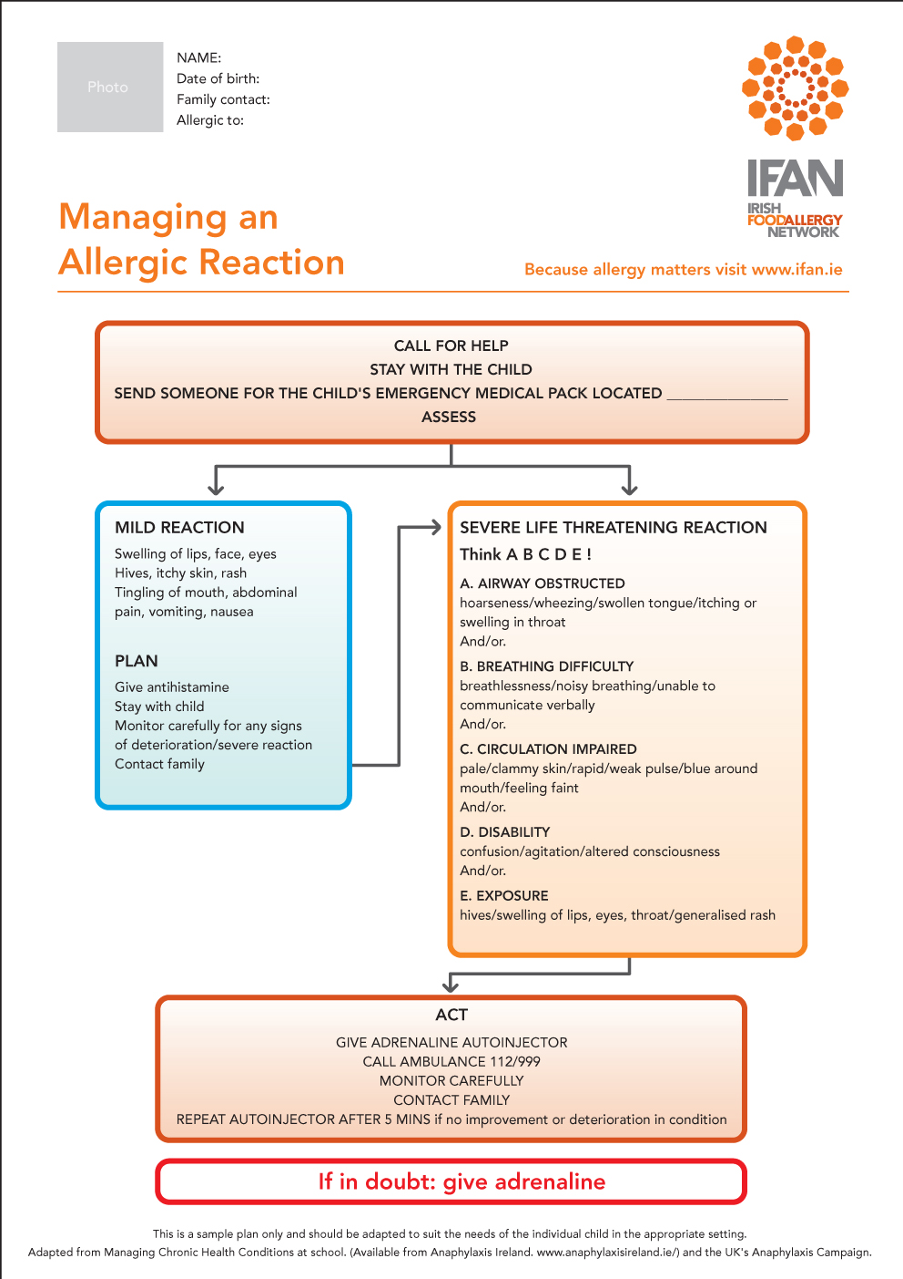

***Appendix 2: Classroom Allergy Alert***

**Substitute Teacher**

**A child in this class has an allergy. Please seek advice from your teaching partner.**

***Appendix 3: Administration of Medication of Pupils Form***



**Administration of Medication to Pupils**

**Request to Board of Management of Gneeveguilla N.S.**

I/We, the parents/guardians of ___________________________ request the Board of Management of Gneeveguilla N.S. to allow a member of staff to give medication to my child ______________________.

I enclose a letter from Dr. ________________________ stating:

* Why the medication is needed.
* Name of Medication.
* When the medication should be administered.
* Dosage to be administered.

Should there be any change in medication I/we will write to the Board of Management to notify them of same.

I/we indemnify the Board of Management in respect of any liability that may arise regarding the administration of medication.

Signed: _________________________ Signed: ________________________  
Parent/Guardian Parent/Guardian

Date: ________________ Date: ________________

***Appendix 4: Administration of Medicine Record Sheet***



**Administration of Medicine Record Sheet**

**Child’s Name: ______________________________**

**Class: _____________________________________**

**Date: ______________________________________**

**Time: ______________________________________**

**Personnel: __________________________________**

**Action Undertaken: ___________________________  
  
_______________________________________________________________________________**

**_______________________________________________________________________________  
  
_________________________________________________________________________________  
  
_________________________________________________________________________________  
  
_________________________________________________________________________________  
  
_________________________________________________________________________________  
  
_________________________________________________________________________________**

**Signed:**

***Appendix 5: Administering the Auto-injector.***

