Gneeveguilla National School

Pupil Well-being Policy
This policy has been formulated by Gneeveguilla NS to assist in the
development of a pupil well-being programme through the Health Promoting Schools initiative.

Contents
Introduction: 3
Whole School Approach to Well-being 3
Benefits of promoting pupil well-being in Gneeveguilla NS 4
The Department’s Wellbeing Policy Statement and Framework 4
Role of teachers 7
School Based Initiatives that Promote Well-being 7
Gneeveguilla NS well-being protective factors 8
Well-being risk factors 9
Stages in the Health Promoting Schools Process that supports well-being 9
.................................................................................................................................................................9
Supporting Individual Pupils: The Student Support Team (SST) 10
Objectives and Rationale for SST: 10
School Support Team and Code of Behaviour 11
Members of the School Support Team: 11
Student referral to the School Support Team: 11
Once a student is referred to the Support Team: 12
Documentation and communication of Support Plans: 12
Confidentiality 13
Communication 13
Essential Elements of the Student Support Team 13
School Support and School Support Plus 13

Meetings 13
Programmes and/or External Facilitators 14
Whole school approach: Indicators of Success 14
Evaluation 15
Link with other policies in the school 15
Appendix 1: Well-being framework 16
Appendix 3: Student Support Team Record Form 21
Appendix 4: SAMPLE RECORDING FORMAT FOR MEETINGS 22
Appendix 5: Student Care Team Review Record 23

Introduction:

Gneeveguilla NS is currently developing a Wellbeing Promotion Process within the school, which is supported by the Department of Education and Skills (DoE) and the Health Service Executive (HSE). It is strongly supported by the “Health Promoting Schools” Model.

“Wellbeing is present when a person realises their potential, is resilient in dealing with the normal stresses of their life, takes care of their physical wellbeing and has a sense of purpose, connection and belonging to a wider community. It is a fluid way of being and needs nurturing throughout life.” (WHO), 2001).

Gneeveguilla NS has a duty to provide the best quality and the most appropriate education in order to promote the wellbeing of our students. We also have a duty to protect students in our care at all times from any potentially harmful, inappropriate or misguided resources, interventions or programmes.

Gneeveguilla NS provides a two-tiered support to pupil well-being;
- Whole School Approach
- Individual Support through Student Support Team

Whole School Approach to Well-being
A multi-component, preventative, whole school approach to the promotion of well-being, with interventions at both universal and targeted levels, is the priority for Gneeveguilla NS. This whole school approach involves all members of the school community engaging in a collaborative process of change to improve specific areas of school life that impact on well-being.

By adopting a whole school approach Gneeveguilla NS aims to produce a wide range of educational and social benefits for our pupils, including improved behaviour, increased inclusion, improved learning, greater social cohesion, increased social capital and improvements to mental health.

This whole school approach supports the integration of systems within the school community. This creates capacity to be reflective and responsive to the needs of our school and the individuals who are part of the school community.

Central to this is the role of Gneeveguilla NS staff and the importance of building professional capacity to engage in a reflective process to implement and sustain well-being policy and strategies from within.

Gneeveguilla NS is in a unique position to promote well-being, and social and emotional learning, and ensures a whole school approach to well-being promotion and early intervention, especially when considering appropriate use of external supports and services.

Students flourish where there is a whole school approach to supporting their growth and where there is a shared belief in their potential for development, learning and well-being. Gneeveguilla NS is responsible for providing an environment that nurtures and supports students.

Benefits of promoting pupil well-being in Gneeveguilla NS
By implementing a whole school approach to well-being the benefits include;
- Better learning results for pupils
- More done to promote staff health
- A co-ordinated approach to social, physical and environmental needs
- Increased pupil self-esteem
- Lowered incidence of bullying
- School environment is safer and more secure
- Better understanding of schools’ health aims
- Improved relationships within the school
- More involvement of parents/guardians
- Better use of outside agencies
- Pupils receive better quality education

The Department’s Wellbeing Policy Statement and Framework

The Department’s Wellbeing Policy Statement and Framework for Practice assists schools in ensuring that well-being promotion is embedded within the school’s existing practice. The school’s review and development process using the Wellbeing Policy Statement and Framework for Practice provides guidance and practical resources to assist in the further enhancement of whole school approaches to well-being promotion in the areas of:

- culture and environment

- curriculum (teaching and learning)
- policy and planning
- relationships and partnerships

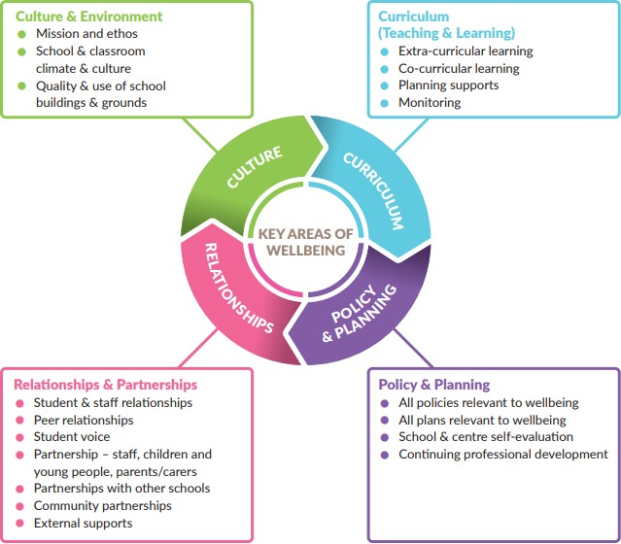

Environment

Gneeveguilla NS aims to foster an environment that enhances competence and well-being; one that consciously fosters warm relationships, encourages participation, develops pupil and teacher autonomy and cultivates clarity about boundaries, rules and positive expectations.

Gneeveguilla NS provides a safe, secure and stimulating environment that encourages and supports pupils, staff and members of the whole school community, both in and out of school. We encourage and promote self-esteem and self-confidence by providing opportunities for all members of the school community to contribute to school life. The school community is encouraged to make healthy choices and to take responsibility for their own health.

Gneeveguilla NS continues to provide a climate in which good relationships, respect and consideration for others prosper, and where individuals are encouraged to make a vital contribution through their personal skills and qualities.

Curriculum and Learning

The teaching and learning in Gneeveguilla NS aims to be democratic, inclusive, engaging, differentiated, fostering expectations of high achievement and providing opportunity for success.
The SPHE curriculum in Gneeveguilla NS strongly supports the social and emotional well-being of our pupils, by placing and emphasis on children’s social and emotional skills, attitudes, behaviour and therefore learning performance.

In line with best practice, the Continuum of Support model delivered within our school offers a flexible framework within which we can address all educational needs, including well-being needs of our pupils.

Gneeveguilla NS adheres to statutory requirements and is accessible to all pupils. We provide challenges for pupils and staff through a wide range of physical, academic, social and community activities.

Policy and Planning

Policies are written documents which support the everyday running of the school through active implementation on a day-to-day basis. They form the background script by which the school navigates its way. They are developed and implemented by the whole school community, not just by one or two people. Parents/guardians and community members are encouraged to participate in policy development through the meeting of our policy development group, which is publicised amongst the entire school community.

Gneeveguilla NS regularly reviews our school policies for staff and pupils that are in accordance with the school aims, philosophy, vision and ethos.

Partnerships
Gneeveguilla NS continues to develop strong partnerships with parents/guardians and the wider community, which is a central part of the well-being process.

We efficiently engage with appropriate agencies and specialist services to advise, support and contribute to health and well-being, teaching and learning

Role of teachers
It is essential that all staff continue to develop their competence and confidence in the promotion of well- being. The qualified classroom teacher is the best placed professional to work sensitively and consistently with students and she/he can have a powerful impact on influencing students’ attitudes, values, and behaviour in all aspects of well-being education.

This can be achieved through accessing continuing professional development (CPD) which includes the sharing of expertise and learning, and having opportunities to model and engage in collaborative working.

School Based Initiatives that Promote Well-being
Gneeveguilla NS implements a number of programmes and initiatives throughout daily school life that support the well-being of our pupils; this list is not exhaustive;
- Aistear: The Early Childhood Curriculum Framework (NCCA, 2009) which encompasses four themes, Well-being, Identity and Belonging, Communication, Exploring and Thinking. This programme runs from Junior Infants to 2nd class.
- Project based learning from 3rd class to 6th class
- SPHE Curriculum (RSE Month, Stay Safe Month, Friendship Week (Anti- Bullying).
- Continuum of Support Model
- Friends for Life (4th, 5th & 6th Class)
- Zippy’s Friends (1st & 2nd Class)
- Student Committees: Health Promoting , Green School Committee, Active School Committee.
- Outdoor Learning
- Internet Safety Workshop – National Parents Council

- External teachers for different strands of PE to promote active living e.g. GAA (weekly),rugby, skipping (developing links/workshops)
- School subsidised swimming lessons – 6 week block for 5th & 6th class pupils
- Healthy Eating- Food Dudes
- Active School Flag initiated in September 2018
- Health Promoting Schools Initiative – since 2012
- School families
- Themed Weeks (e.g. Maths Week, Science Week, Engineers Week, Book Week, Heritage Week etc)
- Promoting the Arts –Annual music workshops e.g. drumming
- Infant Club (2-3 pm) commencing June 2019
- Communicating with National Council for Special Education (NCSE) to gain SNA access for pupils
- Education Welfare Officer – support for pupils with poor attendance
- Links with HSE personnel e.g. Primary Care Team, School Age Team, Early Intervention Team, Assessmenet of Need Team, Brothers of Charity CAMHS.

Gneeveguilla NS well-being protective factors

In Gneeveguilla NS well-being protective factors include:
- positive relationships with peers and teachers - including positive teacher classroom management strategies and a sharing of positive behaviour management practices with parents
- a sense of belonging, security and connectedness to school through a positive school climate and participation in school and community activities
- opportunities for social and emotional learning including the development of attention and planning, self-awareness, self-management, relationship and responsible decision-making skills
- opportunities for the development of knowledge and skills providing a sense of mastery and self- efficacy

- fostering expectations, recognising contributions, effort and achievement and providing opportunities for success
- well-being of school personnel
- protocols and support systems that proactively support children and their families should difficulties arise
- opportunities to develop the necessary skills to cope with using online technology in a safe and appropriate way
- opportunities to develop skills to manage stress that may be linked to school work

Well-being risk factors

In our school setting, well-being risk factors include:
- disengagement, absenteeism, isolation and alienation
- violence/aggression, bullying and relationship difficulties
- low achievement/learning difficulties/special educational needs including social, emotional and behavioural needs
- cultural differences
- school transitions
- poor connection between family and school
- harsh and inconsistent discipline
lack of opportunity to develop social and emotional learning, including problem solving and coping skills.

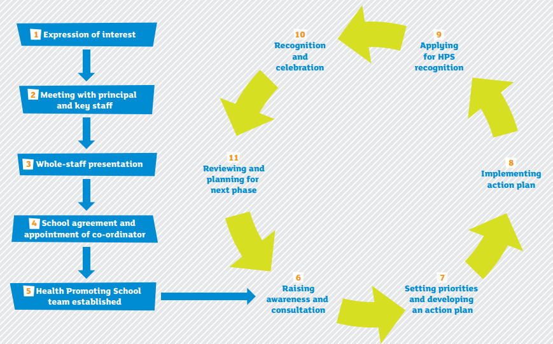
Stages in the Health Promoting Schools Process that supports well-being

Supporting Individual Pupils: The Student Support Team (SST)

The Student Support Team in Gneeveguilla NS. looks after the overall general well-being of students. While it is limited to and by school time we realise that many external issues impinge on the development of students. The purpose of a SST is to provide for students who have a greater need for a higher level of intervention from the school community. The SST is a visible representation of the school’s understanding and valuing of each student as an individual.

The SST ensure effective implementation of a whole school approach which has well-being promotion as part of its responsibility. The Student Support Team (SST) consists of the schools’ Continuum of Support Team, Principal, Deputy Principal and Assistant Principal 2.

The SST meet regularly, and discuss the needs of pupils in the school as a whole, under the continuum of support model. Children may be identified through this process, who would benefit from further support in school, at home and/or from external agencies/bodies.

Objectives and Rationale for SST:
Students who experience difficulties in life will find it difficult to have cognitive space for learning. Therefore the rationale of the SST is to strive to care in a genuine way to improve the lives of students and thereby ensure access to the curriculum and learning.

The SST undertake the following;
- To liaise with external professionals about the welfare of the child
- To liaise with the parents/ guardians of the child
- To share information in a confidential setting
- To coordinate a single transparent response to the care needs of a student
- To review and monitor the students with care needs

The SST is a school-based student services structure that uses resources and staff time efficiently. SST increases student achievement by linking educational interventions with needed support services. SST meet regularly to discuss many students at a single meeting and develop strength-based intervention plans.
Professional services are combined with youth development activities and programs to form “packages of support” for students and families.

School Support Team and Code of Behaviour:
The School Support Team and the Code of Behaviour work together to provide the structure and the care that is necessary for the student to benefit from school. The student may be in the School Support Team and the Disciplinary system at the same time.

Members of the School Support Team:
The core School Support Team is made up of staff and professionals that have direct involvement in the care issues of pupils and various other members depending on the students being discussed.

The following is a list of initial core members.
- Principal:
- Deputy Principal
- Assistant Principal 2: who has responsibility for SPHE curriculum
- Continuum of Support Team; who provide one to one and group support to pupils in need

School Support Team meetings are often used to develop and implement positive programs during school.

Student referral to the School Support Team:

All staff in the school community have a responsibility to be observant of the care needs of the student. Individual staff members need to trust their intuition regarding a student who needs support, outside of what can be provided in the classroom setting. It is in the interest of the student to have a clear referral system.
The process of referral into the school support team will be outlined clearly to staff below. The system below regarding referral should be maintained:
This system is as follows:
- The class teacher will refer a student directly to the School Support Team member assigned to his/her class.
- School support team member will forward information to principal.
- The Principal will then liaise with the relevant members of the School Support Team. A staff member or parent may also refer a student to the Principal or Deputy Principal.
- Administrators and staff members may refer a student directly to the School Support Team

- During parent/guardian meetings following disciplinary actions, teachers often identify the Student Support Team as a resource to help address concerns.
- Parents and guardians who would like to request support may contact a staff member who will advocate for them

Following a referral to the school support team, the teacher will typically call home to arrange a meeting with the parents/ guardians to discuss concerns. The SST member enquires about the pupil’s talents and interests, shares with the parent/ guardian that the School Support Team may be able to help the student to be more successful at school.

Once a student is referred to the Support Team:
- Support plan is initiated for the child
- Intervention plans are developed and a specific staff member is assigned to coordinate the interventions for each student under the supervision of the School Support Team.
- Health, mental health, and culturally appropriate community resources that may be needed are identified during the meeting.
- The team addresses attendance concerns along with the National Educational Welfare Board/Tusla.
- The team addresses specific learning needs along with professionals such as National Educational Psychology Service (NEPs), HSE personnel (Primary Care Team, Assessment of Need Team, Early Intervention Team, School Age Team, Daughter of Charity).
- Cases are brought back to the School Support Team for review.

Documentation and communication of Support Plans:
- Agendas and minutes are shared, however individual children are not identifiable.
- Support plans are drafted, shared with parents for consultation, and then finalised before a programme of support commences.
- Support plans are securely kept in child’s file.
- Any confidential information or information which evokes the implementation of Child Safe Guarding Policy are dealt directly by the Designated Liaison Person – DLP, (or Deputy DLP in their absence), and communicated with parents/guardians.
- Because multiple students are discussed at Student Support Team meetings, students and caregivers do not attend Student Support Team meetings or have access to confidential information. Individual support plans drafted for specific children will be shared with parents.

Confidentiality
An essential element of the School Support Team is maintaining clarity around the boundaries of confidentiality. It is essential for all members of the team, as well as all staff and pupils, to understand the concept of confidentiality in regard to child protection guidelines.

Communication
Clear communication is essential. A person who refers a pupil does not necessarily need to know the details of what has been discussed in relation to the student, but they need to be assured that the student is being cared for.

Essential Elements of the Student Support Team
- Child centred/ advocate for the student
- Non-judgmental
- Solution focused as opposed to problem focused.
- Supported by staff, senior management and BOM
- Optimistic and hopeful
- Accountable through record keeping

School Support and School Support Plus
These lists are intended to inform the staff about students who are identified as requiring additional support and to communicate the work of the student support team.
When a student is on the list, staff will be aware that a key support team member is dealing with that student. This list will also heighten the awareness of staff to any issues arising with the student in the classroom.

It is essential to note that even if a student is on the list that normal code of behaviour applies at all times.

Meetings
The ethos of consistent and regular meetings is central to ensuring the success of the student support team. To formalise and emphasise care of the student, members of the student support team will meet regularly. Additionally, the student support team can conduct meetings at unscheduled dates as needs be e.g. when new children that need support enrol throughout the year.

Programmes and/or External Facilitators
Use of programmes and/or external facilitators can play a role in supplementing, complementing and supporting a planned comprehensive approach to well-being promotion. Programmes and/or external facilitators accessed in Gneeveguilla NS;
- are part of a whole school approach and address an identified need
- are delivered to class groups with the involvement of school staff and the appropriate involvement of parents/carers
- enhance protective factors which predispose students to positive outcomes in the face of adversity such as: facilitating supportive adult-pupil relationships, strengthening life skills, helping students believe in their capacity to overcome hardship and building a sense of mastery over life circumstances
- adopt a planned implementation process, for example, incorporate needs analysis, use evidence informed programmes and track and evaluate outcomes for students
- are implemented and used in a school in a sustained way over a number of years in order to bring about lasting effects and benefits
Please refer to Appendix 2 for checklist

Whole school approach: Indicators of Success
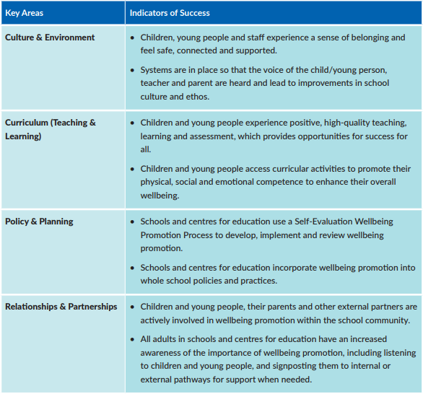

Evaluation
The Gneeveguilla NS team need to be reminded that they need to take care of themselves as well as the students. Reflection and evaluation are necessary. Evaluation forms will be used for this purpose at the end of the academic year.

Evaluation of the pupil well-being programme will take place under the School Self-Evaluation model in 2019/2020.

Link with other policies in the school
The Student Support Team process will link in with the following policies already in existence in the school:
- Code of Behaviour links the discipline structure to the work of the care team
- Anti-Bullying Policy may link with the care team in supporting both the victim and the instigator
- Critical Incident Policy. This is an important policy for the care team as it outlines procedures that a school uses when faced with a trauma such as death of a student.
- Enrolment Policy. It is important to name the care team as part of the school’s commitment to caring for the student and to alert parents to the fact that those students can be referred for internal support.
- Continuum of Support Policy. This policy reflects the fact that students attending learning support or who have special needs may need the support of the care team.
- SPHE Policy. The social, personal and health education of students is an integral part of the curriculum and links in with the care team and guidance.

Gneeveguilla National School

Appendix 1: Well-being framework
Key Area 1 – Culture and Environment

Statements of Effective Practice for All
- The wellbeing of the whole school community is central to the school’s mission statement and management take responsibility to promote wellbeing.
- Parents/carers receive communication and information from schools in relation to initiatives which support the wellbeing of the child/young person.
- All class and subject teachers understand their shared role in supporting learning for and learning about wellbeing in their classroom/subject.
- The relationship between academic achievement and a child/young person’s wellbeing is understood by all children and young people and staff.
- There is a positive approach to discipline where issues are resolved with care, respect and consistency.
- Children and young people and staff have a strong sense of belonging to the school.
- Systems are in place so that the voices of the child/young person, staff and parent/carer are heard.
- Child/young person’s participation within the school community is valued by staff and children and young people are actively supported and encouraged to provide feedback for school improvement.
- The school building, grounds, classrooms and work spaces, are well maintained and appropriately furnished creating a welcoming, safe and warm environment.
- The school building is accessible for all children and young people and accommodation is modified to meet the needs of all.
- Indoor and outdoor space is provided to facilitate social interaction, physical activity and quiet time.
- The school environment is conducive to promoting healthy eating choices.
- The indoor space displays the work, talents and accomplishments of children and young people.
Statements of Effective Practice For Some & Few
The schools demonstrates commitment to identifying, including and providing targeted supports for children and young people experiencing barriers and challenges to wellbeing and learning.
Staff, children and young people are inclusive of those from different cultural backgrounds and those with additional needs.
The physical environment is modified to meet the needs of children and young people with additional and/or complex needs. The following are available if applicable:
- Sensory room/sensory gardens
- ‘Safe’ room/space for distressed/anxious students
- Room(s) for meeting with parents, visiting professionals
- Room(s) for individuals and small groups requiring targeted intervention and support
- Lifting equipment
- Specialist technology
- Buddy bench
*This list is not exhaustive

Key Area 2 - Curriculum (Teaching and Learning)

Statements of Effective Practice for All
All curricular and subject plans have explicit reference to teaching, learning and assessment approaches that promote collaboration, self-assessment and a sense of achievement.
All curricular plans outline how teaching/learning approaches and assessment of learning outcomes will be differentiated for children and young people, providing adequate challenge and opportunities for success.
Teachers use varied teaching and assessment methods and differentiate their expectations to promote full participation and achievement for all.
Teacher continuing professional development (CPD), sharing of learning and reflective practice is encouraged and facilitated through communities of practice.
Throughout primary schools, and in post primary school up to Junior Cycle, the SPHE curriculum is implemented on a mandatory basis.
There is a whole school and coordinated approach to the provision of CSPE, PE and SPHE as part of the Wellbeing Programme at Junior Cycle Level (post primary only).
Children’s and young people’s physical, social and emotional health education are effectively implemented and are a visible part of the Curriculum for SPHE, PE, RSE, CSPE (CSPE - post primary level only).
Appropriate use is made of programmes/resources to support SPHE, RSE, and CSPE.
Universal, evidence-based programmes are appropriately chosen to teach core social and emotional competence and coping skills.
The school links with community-based clubs and organisations to ensure that a broad, accessible and inclusive extra-curricular programme is provided.
Specific national or local initiatives are included in the school’s wellbeing promotion initiatives.
Children and young people, and parents/carers are involved in planning the school’s extra-curricular programme. Children and young people are actively engaged in learning and enjoy coming to school.
Statements of Effective Practice For Some & Few
All curricular plans outline how teaching methods and assessment of learning outcomes will be differentiated for children and young people at risk or with additional and/or complex needs so they experience a sense of achievement.
Teachers attend CPD and deliver specialised and targeted programmes to individuals and/or small groups that are grounded in research and evidence and selected in line with best practice guidelines.
Individualised teaching approaches are linked to specific learning outcomes.
The school deploys resources based on individual learning, behavioural, social and emotional needs under the Teacher Resource Allocation Model.
The Special Education Team and/or Student Support Team support all class and subject teachers and Special Needs Assistants (SNAs) to implement appropriate strategies for children and young people with additional and/ or complex needs and those recommended in professional reports.
Delivery of one to one support teaching is supported by continuing professional development and reflective practice facilitated through communities of practice.
There are opportunities for CPD and ongoing practice support and guidance for SNAs.
Extra-curricular activities are planned to include those with additional and /or complex needs. Children and young people with additional and/or complex needs and their parents/carers are actively involved in planning and evaluating the school’s extra-
curricular programme.

Key Area 3 - Policy and Planning

Statements of Effective Practice for All
The wellbeing of the whole school community is at the heart of school policies and plans.
Consultation with staff, children and young people, and parents/carers is undertaken when developing and reviewing and updating school policies.
Policies are made available to staff, children and young people, parents/carers and relevant partners.
Schools have the following policies, plans and guidelines in place: e.g. Anti-bullying policy and procedures; COS policy; Child protection policy & procedures; Critical Incident Management Plan; Acceptable Use Policy for ICT etc.
All teaching and non-teaching staff are familiar with these policies and procedures. Policies and plans set out how inclusive practice will be implemented.
The school has an established system for gathering information which is conducted in partnership with parents/ carers, children and young people and teachers in order to support the child/young person’s needs.
The school has an established system for gathering information on children and young people at points of transition and uses the Education Passport (NCCA) for children and young people transitioning to post primary school.
Family and child/young person confidentiality is respected at all times and staff follow school guidelines for the appropriate sharing of confidential information.
Records about individual children and young people are stored securely.
The school has a system in place for gathering information on levels of school risk factors such as bullying; absenteeism; truancy; disruptive behaviour.
There is a comprehensive CPD plan to ensure all teachers have the necessary training to promote wellbeing on a whole class basis and through SPHE.
Staff are encouraged to share expertise and learning garnered from CPD by having opportunities to model and engage in collaborative working.
The school adheres to DES circular on the use of programmes and/or external speakers.
At post primary level, the whole school Guidance Plan sets out how Student Support Teams will operate. The school identifies and participates in specific national or local initiatives for wellbeing promotion.
Statements of Effective Practice For Some & Few
The school’s COS policy specifically lays out how the screening, gathering of information and planning of interventions for children and young people with additional and/or complex needs is undertaken.
School-based information is used in conjunction with reports from external professionals which, set guidelines and recommendations for individualised supports.
The school engages with collaborative problem-solving to support a child/young person’s needs, identified through the NEPS Continuum of Support. A student support file is used to plan, record and review progress.
The COS policy identifies a range of evidence-based strategies and programmes for groups at ‘further risk’ of developing mental health difficulties.
The school’s assessment policy outlines how additional school-based screening and intervention tools are used to assess social, emotional and behavioural difficulties.
The school’s COS policy and plan sets guidelines for individualised supports to help those with complex needs understand and engage with school policies e.g. bullying, code of behaviour.
The school has mechanisms in place for identifying vulnerable students in the event of a critical incident.

Key Area 4 - Relationships & Partnerships

Statements of Effective Practice for All
Relationships between teachers, children and young people and parents/carers are characterised by openness, respect and listening.
Relationships and partnerships are supported through a range of agreed formal and informal structures, for example, student councils, prefect systems, buddy systems, mentoring systems, assemblies and newsletters.
The views of all staff and children and young people are sought, listened to and respected.
The views of parents/carers are accessed through questionnaires, focus groups, parent councils and feedback from parent-teacher meetings.
Parent-teacher meetings are convened on a mandatory basis, to discuss children and young people’s progress.
The board of management promotes the establishment of a parents’ council in the school, and co-operates with the council as needed.
Staff receive recognition and support from management.
All staff members are aware of the Employee Assistance Service. The school establishes links with feeder schools.
The school establishes strong working relationships with other schools and engages in sharing of best practice. The school promotes professional networks for principals and subject teachers.
The school establishes good links with Department support services, community-based statutory and voluntary support services and other external agencies.
There are clear referral pathways and the roles and responsibilities of agencies are agreed and understood by all.
The school supports extra-curricular activities by linking with sports clubs, dance clubs and bands, scouts, work experience placements, charity organisations etc.
For Some & Few
Mentoring systems are in place whereby more senior teachers offer practical and social support to Newly Qualified Teachers (NQTs) and/or new staff members.
Staff receive individualised support from management in times of difficulty or during personal crisis and are given information and contact details for the Employee Assistance Service.
Mentoring systems are in place whereby more senior young people mentor younger children offering practical, social and/or emotional support.
Befriending and buddy systems are in place for children and young people who require support to interact with peers.
Efforts are made to build positive relationships with children and young people who are experiencing challenges, and with their parents. They may have a ‘named staff member’ allocated to them to act as the ‘one good adult’.
Children and young people and their parents/carers are included in collaborative problem solving and decision- making with regard to individualised support and interventions.
Children and young people have access to one to one meetings with qualified members of staff to support their personal and social, educational and career development, and at moments of personal crisis.
The primary school links with the feeder post primary schools and holds sixth class transfer review meetings, for those children and young people with additional and/or complex needs.
Primary schools link with the local Early Childhood Care and Education Scheme (ECCE) to support the transition of children with additional and/or complex needs into the primary setting.
Centres of education link with other training centres and employees to ensure successful transfers from the centre. The school attaches a high value to support networks for guidance counsellors and SEN teachers.
The school has established working relationships with DES support services and other agencies and services involved in supporting the mental health of children and younger people.

Appendix 2: Checklist: Use of Programmes and/or External Facilitator

Engaging External Facilitators in the School: |  |  | 
1. | The facilitators have the necessary training/qualifications and expertise to deliver the agreed programme or training
2. | At least one member of the school team is available to facilitate  planning, joint delivery and evaluation of the programme or external input
3. | Facilitators are suitably qualified to work with the profile of students in  the school
4. | Facilitators delivering the programme or input have a written child protection policy and a safeguarding statement
5. | The school is satisfied that it has met any vetting obligations that arise  under the Vetting Act and in line with Circular 0031/2016, for the external facilitators
When Considering a Programme: |  |  | 
6. | A need has been identified through the school’s Wellbeing Promotion Process that could be addressed by using a specific programme
7. | The programme is consistent with the school’s whole school approach to wellbeing promotion
8. | The Board of Management has approved the delivery of the programme
9. | The chosen programme is informed by research and/or evidence
10. | The programme uses evidence based/informed methodologies and promotes active learning
11. | All relevant staff members have been informed about the proposed programme.
12. | The programme is suitable to meet the needs of the targeted cohort of  students.
13. | In the selection of programmes, the opinions of parents/carers and students have been ascertained
14. | An evaluation form will be completed by students and staff
15. | The impact of the programme will be monitored
16. | The programme delivery is sustainable over time within the school
17. | Consideration has been given to the possible vulnerabilities of students and the minimising of any potential negative impact of the programme
18. | Supports are available for the students during and after the programme delivery

Appendix 3: Student Support Team Record Form –
CONFIDENTIAL PRINCIPAL ONLY

Child’s Name: | D.O.B: | Age: | Sex: Male Female
Teacher: | Class: | Primary language:
Parent Name: | Phone: | Address:

Support Child Currently Receives: check all relevant areas
 | Classroom Support |  | School Support |  | School Support Plus |  | Mutli-disciplinary
 | Psychology |  | Speech, Language |  | O.T. Support |  | Other

Academic Concerns: check all relevant areas
 | Phonemic Awareness |  | Vocabulary |  | Math Calculation |  | Speech/Articulation
 | Phonics |  | Comprehension |  | Math Problem Solving |  | Fine Motor Skills
 | Fluency |  | Written Language |  | Oral Language |  | Gross Motor Skills

Behaviour/Social/Medical Concerns: check all relevant areas
 | Aggressive |  | Disorganised |  | Anxious |  | Angry |  | Confused
 | Passive |  | Distractive |  | Fearful |  | Argues |  | Vision
 | Social Skills |  | Immature |  | Withdrawn |  | Defies/Refuses |  | Hearing
 | Tardy / Truant |  | Impulsive |  | Physical complaints |  | Blames others |  | Other Medical
 | Disrupts Class |  | Hyperactive |  | Seems depressed |  | Lies
 | Attention |  | Does not Listen |  | Lethargic / Fatigued |  | Steals |  | Other
 | Doesn’t Retain |  | Fidgets |  | Sleeps in class |  | Cheats
 | Inconsistent |  | Interrupts |  | Hygiene |  | Destroys property

Please photocopy observations/monitoring details of child in areas of concern and attach

List interventions provided to date:
What do you hope to achieve by this referral:

Requested By: | Form Completed by:
Date parents notified: | Date form completed:

Appendix 4: SAMPLE RECORDING FORMAT FOR MEETINGS

Student Support Team Meeting
Date:
 | From | Student | Risk* | Concerns** | Follow-up***
Junior Infants | year group | Student’s initials |  | category of problem
 | Chest. | S o’m | 1 | Emotional | COS teacher to meet with parents
 | Ash | P T | 2 | Behavioural
2nd Class
 | Hazel | T.T. | 4 | Behavioural / Emotional | NEPS advice, possible referral to Cámhs
3rd Class
 | Lime | A.M. | 2 | Social | COS Support – Classroom Level
4th Class
 | Beech | E D | 3 | Emotional | Consult NEPS psych.

*Risk is rated from 1- low risk to 5 - high risk (immediate action required).
** Concerns are phrased in categories according to the MAIN presenting problem:
∂ Behavioural – acting out; aggressive; bullying…
∂ Emotional – family or personal problems; grief …
∂ Social – isolated; fighting…
***Follow-up refers to the individual(s) who will be reporting back on that student following some action.

Gneeveguilla National School

Appendix 5: Student Care Team Review Record

STUDENT CARE TEAM REVIEW RECORD: |  |  | Date:
Name | Positive Changes | Ongoing Concerns | Current Needs | Action

